  Gold Price Prediction Analysis Report | Abstract  This project develops a machine learning-based system to predict gold prices using key financial indicators: the S&P 500 Index (SPX), United States Oil Fund (USO), Silver Price (SLV), and the EUR/USD exchange rate. Through analysis of historical data (2008-2018), a Random Forest model was trained and achieved a high prediction accuracy of 98.97% (R² score), significantly outperforming other tested models. The system is deployed via a user-friendly Streamlit web application, enabling real-time gold price forecasts. This tool provides valuable insights for investors and financial analysts, demonstrating the effective application of machine learning in commodity price prediction.  Tanmay Bhongale Praful Tikkas Aditya Jadhav  MACHINE LEARNING

1. Executive Summary
This project develops a machine learning system to predict gold prices based on four key economic indicators: S&P 500 Index (SPX), United States Oil Fund (USO), Silver Price (SLV), and EUR/USD exchange rate. The system consists of two main components:
- Data Analysis & Model Training (Jupyter Notebook): Historical data analysis and machine learning model development
- Deployment Application (Streamlit): User-friendly web application for real-time predictions
The Random Forest model achieved an impressive 98.97% accuracy (R² score), outperforming other tested algorithms including Linear Regression, Decision Tree, and XGBoost.
2. Project Architecture
2.1 Technology Stack
- Programming Language: Python 3.x
- Data Processing: Pandas, NumPy
- Visualization: Matplotlib, Seaborn
- Machine Learning: Scikit-learn, XGBoost
- Model Persistence: Joblib
- Deployment: Streamlit
- Development Environment: Jupyter Notebook & VS Code
2.2 Data Pipeline
Data Collection → Data Cleaning → Exploratory Analysis → Feature Engineering → Model Training → Model Evaluation → Deployment
3. Dataset Analysis
3.1 Data Overview
- Source: gold_model_dataset_2008_2018.csv
- Time Period: 2008-2018 (10 years)
- Records: 2,290 daily observations
- Features: 6 columns including date and 5 financial indicators
3.2 Feature Description
- Date: Daily timestamp (2008-2018)
- SPX: S&P 500 Index (Stock market indicator)
- GLD: Gold Price (Target variable)
- USO: United States Oil Fund (Oil price indicator)
- SLV: Silver Price (Precious metal indicator)
- EUR/USD: Euro to US Dollar exchange rate (Currency indicator)
3.3 Statistical Summary
Feature | Mean | Median | Standard Deviation | Min | Max | Range
SPX | $1,654.32 | $1,551.43 | $519.11 | $676.53 | $2,872.87 | $2,196.34
GLD | $122.73 | $120.58 | $23.28 | $70.00 | $184.59 | $114.59
USO | $31.84 | $33.87 | $19.52 | $7.96 | $117.48 | $109.52
SLV | $20.08 | $17.27 | $7.09 | $8.85 | $47.26 | $38.41
EUR/USD | $1.28 | $1.30 | $0.13 | $1.04 | $1.60 | $0.56
3.4 Data Quality Assessment
- Missing Values: None detected after cleaning
- Duplicates: No duplicate dates found
- Data Types: Appropriate data types assigned
- Formatting: USO values rounded to 2 decimal places
4. Exploratory Data Analysis
4.1 Correlation Analysis
The correlation matrix revealed key relationships:
Feature | Correlation with Gold (GLD)
SLV | 0.87 (Strong Positive)
USO | -0.19 (Weak Negative)
SPX | 0.05 (Very Weak Positive)
EUR/USD | -0.02 (Negligible)
Key Insight: Silver price (SLV) shows the strongest positive correlation with gold, making it the most important predictor.
4.2 Visual Insights
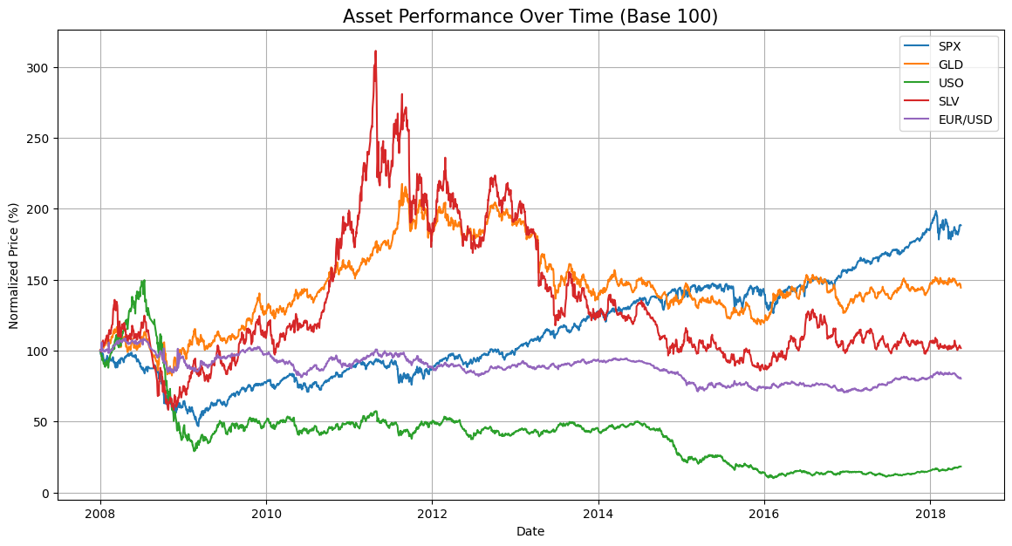
- Time Series Analysis: All assets showed significant volatility during the 2008 financial crisis
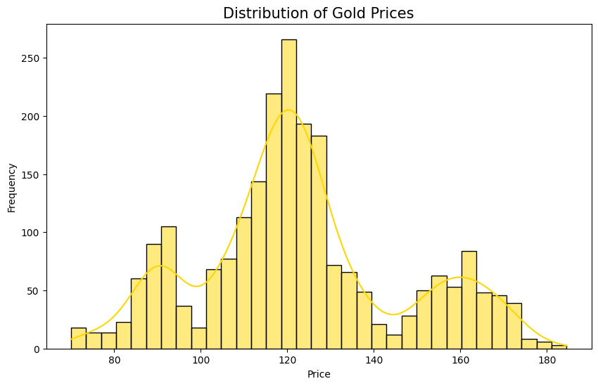
- Gold Distribution: Gold prices followed a roughly normal distribution centered around $120

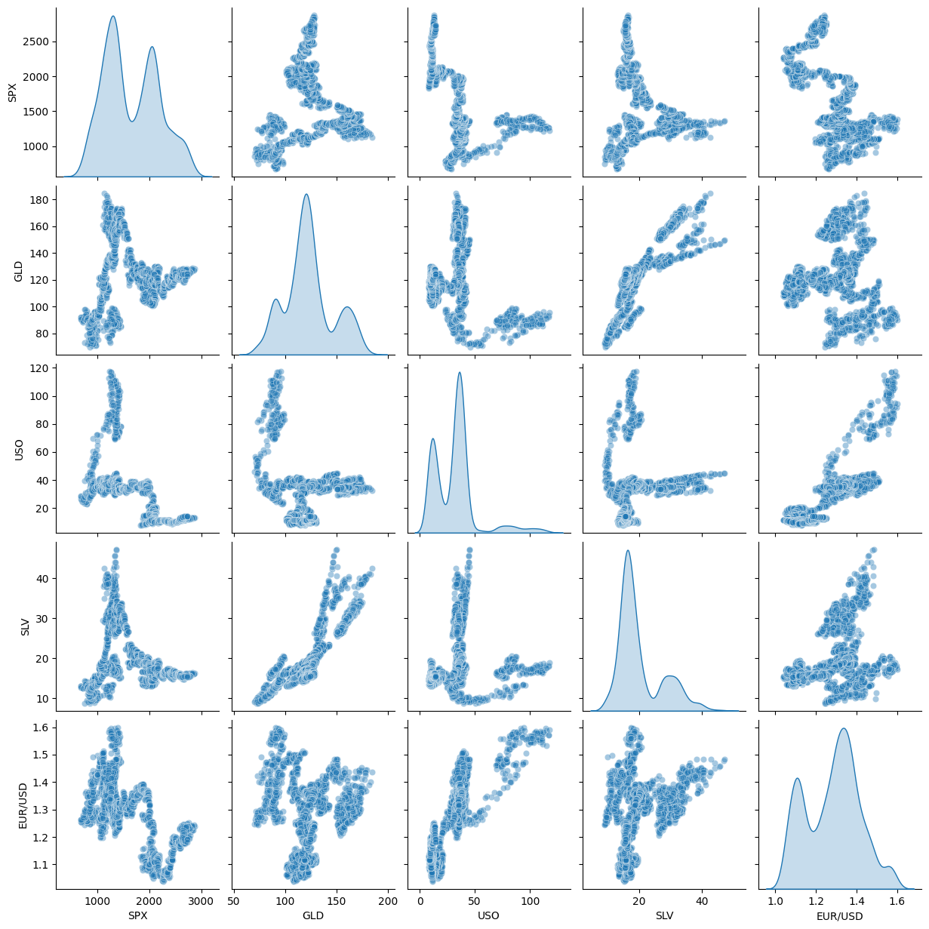
- Pair Plots: Revealed complex nonlinear relationships between variables

5. Machine Learning Models
5.1 Data Preparation
- Target Variable: GLD (Gold Price)
- Features Used: SPX, USO, SLV, EUR/USD (Date excluded)
- Train-Test Split: 80% training (1,832 samples), 20% testing (458 samples)
- Random State: Fixed at 2 for reproducibility

5.2 Model Performance Comparison
Model | R² Score | Performance Assessment
Random Forest | 0.9897 | Best Performance
XGBoost | 0.9874 | Excellent performance
Decision Tree | 0.9856 | Very good performance
Linear Regression | -0.8658 | Completely unsuitable

5.3 Model Selection Rationale
Random Forest was selected as the final model because:
- Highest Accuracy: 98.97% R² score indicates exceptional predictive power
- Robustness: Handles non-linear relationships well
- Feature Importance: Naturally ranks feature importance
- Overfitting Prevention: Through ensemble averaging
5.4 Model Persistence
The trained Random Forest model was saved as RandomeForest.joblib for deployment.
6. Deployment Application
6.1 Streamlit Application Features
GOLD PRICE PREDICTION APP
This app predicts Gold Price based on
various economic indicators
SPX: [1000.0] ← User Input
USO: [50.0] ← User Input
SLV: [20.0] ← User Input
EUR/USD: [1.1] ← User Input
PREDICT GOLD PRICE] ← Button
Result: $XXX.XX
6.2 Application Workflow
- User inputs current values for four economic indicators
- Application loads the pre-trained Random Forest model
- Model processes inputs and generates prediction
- Predicted gold price displayed in USD
6.3 Input Guidelines
- SPX: Current S&P 500 Index value (e.g., 4500.0)
- USO: Current US Oil Fund price (e.g., 75.0)
- SLV: Current silver price per ounce (e.g., 25.0)
- EUR/USD: Current exchange rate (e.g., 1.08)
7. Business Insights & Applications
7.1 Key Findings
- Silver-Gold Relationship: Strong positive correlation (0.87) suggests these precious metals often move together
- Oil-Gold Relationship: Weak negative correlation (-0.19) indicates inverse relationship during the period
- Market Independence: Gold shows low correlation with stock market (SPX) and currency (EUR/USD)
7.2 Practical Applications
- Investment Decision Support: Helps investors time gold purchases/sales
- Portfolio Management: Assists in asset allocation decisions
- Risk Management: Provides quantitative basis for hedging strategies
- Financial Planning: Supports long-term financial planning
7.3 Limitations
- Time Period: Data limited to 2008-2018 (pre-COVID era)
- Market Shocks: Model may not account for unprecedented events
- Feature Set: Only four indicators used; additional features could improve accuracy
- Assumptions: Assumes historical relationships will persist
8. Conclusion
This Gold Price Prediction system successfully demonstrates:
- Effective Data Analysis: Comprehensive exploration of financial relationships
- Robust Model Development: Random Forest algorithm with 98.97% accuracy
- Practical Deployment: User-friendly Streamlit application
- Actionable Insights: Clear understanding of gold price drivers
The project provides a solid foundation for financial decision-making and can be extended for professional trading applications, portfolio management, and economic research.

